REST SPECIFICATION TEMPLATE

Document Number: <###>

Document Version: : <V#.#>

Date: mmm, yyyy

Document Status: Draft

# NOTICE

Copyright © TeleManagement Forum 2013. All Rights Reserved.

This document and translations of it may be copied and furnished to others, and derivative works that comment on or otherwise explain it or assist in its implementation may be prepared, copied, published, and distributed, in whole or in part, without restriction of any kind, provided that the above copyright notice and this section are included on all such copies and derivative works. However, this document itself may not be modified in any way, including by removing the copyright notice or references to TM FORUM, except as needed for the purpose of developing any document or deliverable produced by a TM FORUM Collaboration Project Team (in which case the rules applicable to copyrights, as set forth in the [TM FORUM IPR Policy](http://www.tmforum.org/IPRPolicy/11525/home.html), must be followed) or as required to translate it into languages other than English.

The limited permissions granted above are perpetual and will not be revoked by TM FORUM or its successors or assigns.

This document and the information contained herein is provided on an "AS IS" basis and TM FORUM DISCLAIMS ALL WARRANTIES, EXPRESS OR IMPLIED, INCLUDING BUT NOT LIMITED TO ANY WARRANTY THAT THE USE OF THE INFORMATION HEREIN WILL NOT INFRINGE ANY OWNERSHIP RIGHTS OR ANY IMPLIED WARRANTIES OF MERCHANTABILITY OR FITNESS FOR A PARTICULAR PURPOSE.

Direct inquiries to the TM Forum office:

240 Headquarters Plaza,

East Tower – 10th Floor,

Morristown, NJ  07960 USA

Tel No.  +1 973 944 5100

Fax No.  +1 973 944 5110

TM Forum Web Page: [www.tmforum.org](http://www.tmforum.org/)

TM Forum Web Page: [www.tmforum.org](http://www.tmforum.org/)

# Table of Contents

NOTICE 2

Table of Contents 3

List of Tables 4

Introduction 5

SAMPLE USE CASES 7

RESOURCE MODEL 9

Managed Entity and Task Resource Models 9

Service qualification Resource 9

Order feasibility check Resource 12

Event Models 17

API OPERATION TEMPLATES 18

GET /api/serviceQualificationRequest?{filter_representation} 19

POST /api/serviceQualificationRequest 21

GET /api/orderFeasibilityCheckRequest 27

POST /api/orderFeasibilityCheckRequest 31

API NOTIFICATION TEMPLATES 35

Release History 36

# List of Tables

Table 1 Service Qualification field description 11

# Introduction

Service Qualification API is One of Pre-Ordering Management API Family. Service Qualification API goal is to provide service availability at Customer location.

In the Open Digital Economy where multiple actors (SDPs, CSPs, …) may be involved with the delivery of an end-to-end service, those actors need to collaborate and interact with the customer as needed.

ServiceQualification API operation checks are modeled as requests:

- serviceQualification request checks technical eligibility (Service Qualification Request resource),

- orderFeasibilityCheck request checks commercial Eligibility include technical eligibility. (OrderFeasibilityCheck resource)

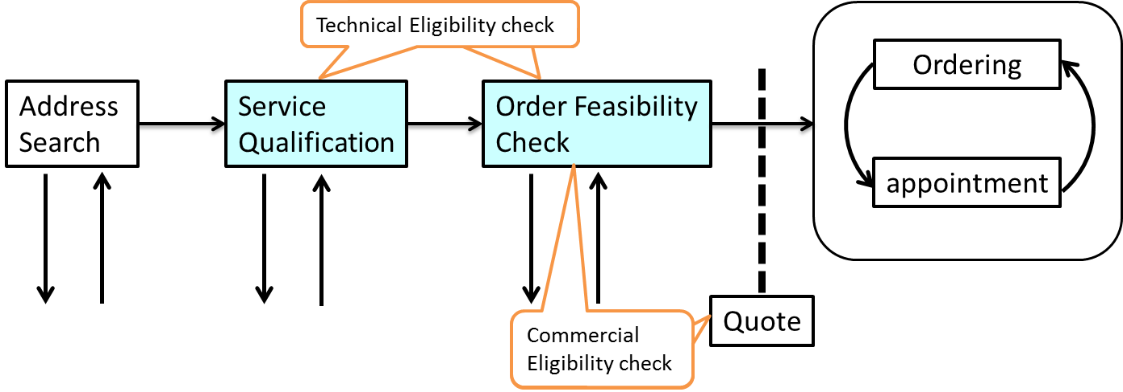

Depending on the way to describe “Product “, it may be classified in either technical feasibility or commercial feasibility.

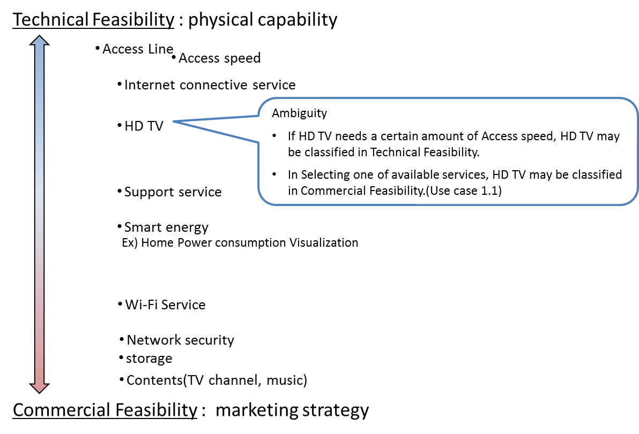

# SAMPLE USE CASES

The following table maps out the use case.

|  |  |
| --- | --- |
| **UC** | **description** |
| 1 | A ‘new’ **customer** is browsing operator internet services webpage and **wish to see** which **offers** he is **eligible** with his current address. The **system** **retrieves** the **list of offers** technically eligible **with characteristics and configuration**. |
| 1.1 | Configuration could be detailed and for example the **customer** is **informed** that he is **eligible** **for** ADSL, TV online but he cannot have both TV HD and Multi-Screen TV options (just **one of these**). |
| 2 | A ‘new’ **customer** is interested for FTTH service – he **asks** to SP sale representative about **FTTH** service at his current address. Thus **system indicate** he is **eligible to FTTH** and he will have a **xx Mo/s speed** for download and yy for upload. |
| 2.2 | Alternative: the address is **ok for FTTH** service but from a strictly technical point of view the operator **FTTH center box** have **not enough space** to plug a new connection. The **Sale** representative is able to **inform** the customer that he will be **eligible to FTTH in 8 week** |
| 3 | a **customer wishes to enjoy HD TV.** He asks to SP sale representative. He is **eligible** but he **has to change** his **access** offer. |
| 3.1 | Alternative: **Access is ok** but system checks that he is currently using an outdated TV decoder and he has to **upgrade** his **TV box** to enjoy HD. |
| 4 | A **customer** **askes for TV on internet.** An eligibility **check** is triggered and should check not only the **TV channel** provided **by the SP** but also the additionally **TV channels availability** at the customer address (even if they not directly provided by the SP). |
| 5 | A **customer** is moving to a new address – a **check** must be done at this new **address** and the **SP** sale representative is able to **inform** the customer if:   * he will be **able to keep** current offer at his new address * he **should downgrade** his services because current ones are not technically feasible at the new address * he can keep but also he is **eligible to** an **upgrade** and benefit for example to a FTTH broadband at his new address. |
| 6 | A **TV channel provider** wants to sell a set of channel for a customer. He will ask for the customer **broadband company** [API provider] and an **access id** (email address for example). He will use this information with this POST /serviceQualificationRequest api to be able to **retrieve** information on customer **access capabilities** (and check if the customer will be able to get his service from the service point). |
| 7 | A **MVNO/other provider** who use provider network will call this api to be able to **check capabilities** for one prospect. With this api he will have all technical information and he should have to apply his own commercial rules to make a proposal to this customer. This UC could be a mandatory one for contractual reason where network is still owned by legacy Telco Company but they have to open it for competitors. |
| 8 | this api could be used in **internal channel** to be able to check technical **capabilities** without any commercial filter. It could be useful in some customer support UC. |

# RESOURCE MODEL

## Managed Entity and Task Resource Models

Service Qualification API has 2 Resources (subclassing Business Interaction ).

Service Qualification Request resource for knowing the allowed services based on specific criterions such as

* location
* physical resource

OrderFeasibilityCheck resource for knowing the product offering based on specific criterions such as

* location
* physical resource
* service types
* Ordering party role

### Service qualification Resource

Example of the JSON representation of Service Qualification:

Service provider execute service qualification request with location information to get technical eligibility that is network access speed, available service list.

|  |
| --- |
| "serviceQualificationRequest" :  {  "id" : "42",  "interactionDate" : "20160201 10:00",  "description" : "service qualification check",  "interactionDateComplete" : "20160201 10:01",  "interactionStatus" : "close",  "place" : {  "type" : "geographical"  "id" : "12345678",  "externalRef" : "https://www.google.ca/maps/dir/''/google+map+montreal+place+ville+marie/@45.5014452,-73.6393962,12z/data=!3m1!4b1!4m8!4m7!1m0!1m5!1m1!1s0x4cc91a4498f8f3db:0xa2760b4a779d61d3!2m2!1d-73.5693564!2d45.5014666",  "id":"7513180",  "href":"addresses/7513180",  "streetNr": "29",  "streetName": "Rambeau",  "streetType": "Rue",  "postcode": "31330",  "city": "Merville",  "country": "France",  "geoCode": {  "latitude": "1.296349",  "longitude": "43.717627",  "geographicDatum": "WGS84"  }  },  "physicalResource" : {  "accessType" : "ADSL",  "availability" : "serviceable" ,  "upstreamSpeed" : "1Mb",  "downstreamSpeed" : "10Mb"  },  "serviceQualificationRequestItem" : {  "serviceAvailability" : [  "service" : {  "id" : "service_id_0",  "href" : "http://service/HDTV",  "serviceSpecification" {  "id" : "3333",  "href": "//serviceSpecification/HDTV-Premium"  },  "serviceCharacteristic" {  "name" : "Multi-Screen TV",  "value" : "false"  },  "availability" : "serviceable",  "serviceabilityDate" : "20160201 00:00"  },  "service" : {  "id" : "service_id_1",  "href" : "http://service/MultiScreenTV",  "serviceSpecification" {  "id" : "3333",  "href": "//serviceSpecification/Multi-ScreenTV"  },  "serviceCharacteristic" {  "name" : "HD TV",  "value" : "false"  },  "availability" : "serviceable",  "serviceabilityDate" : "20100201 00:00"  }  }  } |

For each resource in your model fill the following table.

fields Description

|  |  |
| --- | --- |
| Field | Description |
| id | Unique identifier for Interaction. |
| interactionDate | Date interaction initiated. |
| description | Narrative that explains the interaction and details about the interaction, such as why the interaction is taking place. |
| interactionDateComplete | The date on which an interaction is closed. |
| interactionStatus | The current condition of an interaction.  In the serviceQualification request case, response state is close only in synchronous interaction. |
| place |  |
| type | Unique identifier for Place |
| id | Unique identifier for Place |
| href | Reference of a place (for instance in google map) |
| physicalResource |  |
| accessType | Access Technology Type: ADSL, VDSL, fiber |
| availability | Technical eligibility result: true/false/unknown |
| upstreamSpeed | Upload speed |
| downstreamSpeed | Download speed |
| serviceQualificationRequestItem |  |
| serviceAvailability | services with a specific eligibility check will be listed there with technical eligibility result |
| service |  |
| id | Service identifier |
| availability | Technical Eligibility result. |
|  |  |
|  |  |
|  |  |

Table 1 Service Qualification field description

Serviceability status may be represented below tables.

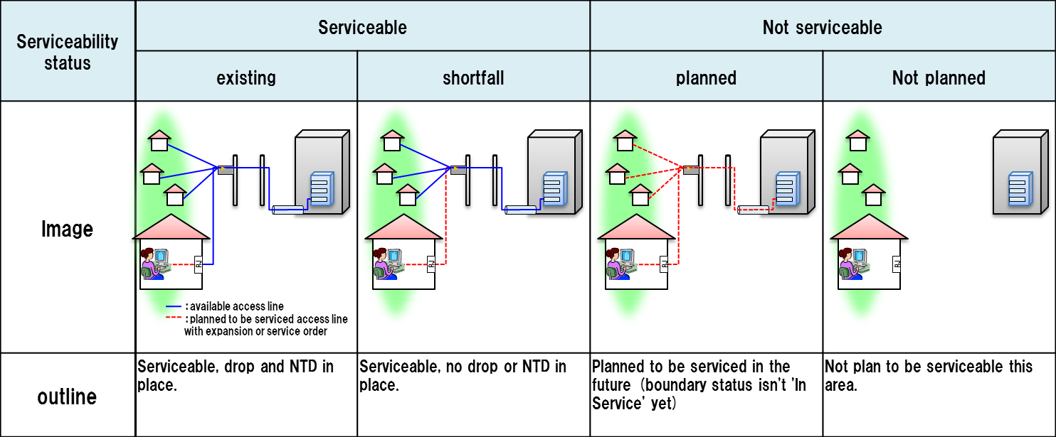

serviceable-shortfall is include updating access NW.

substatus are captured via .notation

i.e serviceable.existing etc…

### Order feasibility check Resource

Example of the JSON representation of Order Feasibility check:

Service provider execute order feasibility check request to get the customer location Feasibility include Commercial and Technical eligibility.

|  |
| --- |
| "OrderFeasibilityCheckRequest" :  {  "id": "142",  "href": "http://server/orderFeasibilityCheck/142",  "interactionDate" : "20160201 10:00",  "description" : "service qualification check",  "interactionDateComplete" : "20160201 10:01",  "interactionStatus" : "close",  "partyRole" : "Service Provider",  "place" : {  "type" : "geographical"  "id" : "12345678",  "href":"addresses/12345678",  "streetNr": "29",  this is optional….  "streetName": "Rambeau",  "streetType": "Rue",  "postcode": "31330",  "city": "Merville",  "country": "France",  "geoCode": {  "latitude": "1.296349",  "longitude": "43.717627",  "geographicDatum": "WGS84"  }  "externalRef" : "https://www.google.ca/maps/dir/''/google+map+montreal+place+ville+marie/@45.5014452,-73.6393962,12z/data=!3m1!4b1!4m8!4m7!1m0!1m5!1m1!1s0x4cc91a4498f8f3db:0xa2760b4a779d61d3!2m2!1d-73.5693564!2d45.5014666",  },  "physicalResource" : {  "accessType" : "fiber",  "availability" : "serviceable" ,  "upstreamSpeed" : "10Mb",  "downstreamSpeed" : "100Mb"  },  "orderFeasibilityCheckRequestItem": [  "serviceAvailability" : [  "service" : {  "id" : "service_id_0",  "href" : "http://server/service/service_id_0",  "serviceSpecification" {  "id" : "3333",  "href": "//serviceSpecification/Basic-HDTV"  },  "availability" : "serviceable",  "serviceabilityDate" : "20160201 00:00"  },  "service" : {  "id" : "service_id_0",  "href" : "http://server/service/service_id_0",  "serviceSpecification" {  "id" : "3333",  "href": "//serviceSpecification/HDTV-Premium"  },  "availability" : "serviceable",  "serviceabilityDate" : "20160201 00:00"  }  ],  "productAvailability": [  "productOffering": {  "id": "2222",  "href": "http://server/catalogManagement/product/HDTV-Premium ",  name": " HDTV-Premium ",  "productSpecification": {  "id": "2424",  "href": [http://server/catalogManagement/productspecification/HDTV-Premium](http://server/catalogManagement/productspecification/HDTV-Premium%20) ,  name": " HDTV-Premium ",  },  ],  "availability": "serviceable",  "serviceabilityDate": "20160201 00:00"  },  "productOffering": {  "id": "2222",  "href": "http://server/catalogManagement/product/ Basic-HDTV ",  name": " Basic-HDTV ",  "productSpecification": {  "id": "2424",  "href": http://server/catalogManagement/productspecification/ Basic-HDTV”  name": " Basic-HDTV ",  },  ],  "availability": "serviceable",  "serviceabilityDate": "20160201 00:00"  },  ]  ]  } |

For each resource in your model fill the following table.

fields Description

|  |  |
| --- | --- |
| Field | Description |
| id | Unique identifier for Interaction. |
| interactionDate | Date interaction initiated. |
| description | Narrative that explains the interaction and details about the interaction, such as why the interaction is taking place. |
| interactionDateComplete | The date on which an interaction is closed. |
| interactionStatus | The current condition of an interaction in the Business interaction.  In the OrderFeasibilitycheck request case, response state is close only in synchronous interaction. |
| place |  |
| id | Unique identifier for Place |
| href | Reference of a place (for instance in google map) |
| PhysicalResource |  |
| accessType | Access Technology Type: ADSL, VDSL, fiber |
| Availability | Technical eligibility result |
| upstreamSpeed | Upload speed |
| downstreamSpeed | Download speed |
| orderFeasibilitycheckRequestItem |  |
| serviceAvailability | services with a specific eligibility check will be listed there with technical eligibility result |
| service |  |
| id | Service identifier |
| availability | Technical Eligibility result |
| productAvailability | top-level product offerings based on the technology |
| productOffering |  |
| id | ID of the top level productOfferi,ng |
| availability | Commercial and Technical eligibility result for this offer: |
| relatedParty | Party who ask order Feasibility |
|  |  |

For each resource in the API provide a UML model:

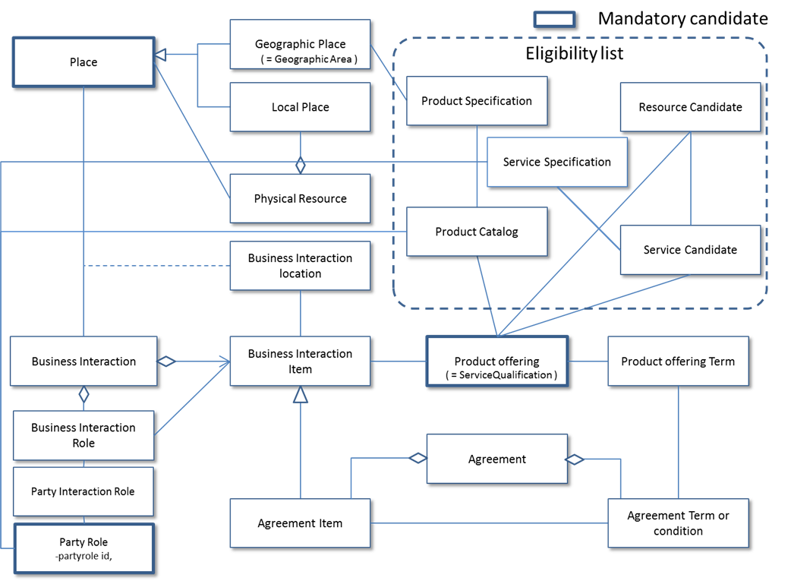

Figure 1 – Service Qualification resource model

# Event Models

Service Qualification API has no notification event.

# API OPERATION TEMPLATES

For every single of operation on the entities use the following templates and provide sample REST requests and responses.

Remember that the following Uniform Contract rules must be used :

|  |  |  |
| --- | --- | --- |
| Operation on Entities | Uniform API Operation | Description |
| Query Entities | GET Resource | GET must be used to retrieve a representation of a resource. |
| Create Entity | POST Resource | POST must be used to create a new resource |
| Partial Update of an Entity | PATCH Resource | PATCH must be used to partially update a resource |
| Complete Update of an Entity | PUT Resource | PUT must be used to completely update a resource identified by its resource URI |
| Remove an Entity | DELETE Resource | DELETE must be used to remove a resource |
| Execute an Action on an Entity | POST on TASK Resource | POST must be used to execute Task Resources |
| Other Request Methods | POST on TASK Resource | GET and POST must not be used to tunnel other request methods. |

Filtering and attribute selection rules are described in the TMF REST Design Guidelines.

Notifications are also described in a subsequent section.

## GET /api/serviceQualificationRequest?{filter_representation}

Description :

This operation is used to provide technical Eligibility that is what service is available or when the service is available.

Partner used this API to notice service availability Partner’s customer.

GET operation use if location id is created at other API/system.

|  |  |  |  |
| --- | --- | --- | --- |
| **Attribute name** | **Mandatory** | **Default** | **Rule** |
| Location id | Y |  | Location id is mandatory if Address info is empty. |
| Address info | Y |  | Address info is mandatory if Location id is empty. |
| Technical aspect | N |  |  |
|  |  |  |  |

Behavior :

* Return status codes
  + 200 OK – the request was successful
  + 400 Bad Request – error, for example to cover these functional error cases:
    - Location is not exist

Use case : Get access network service availability from location id

|  |
| --- |
| **REQUEST** |
| GET /api/serviceQualificationRequest?place.id=12345678;  Accept: application/json |
| **RESPONSE** |
| 200  Content-Type: application/json  "serviceQualificationRequest" :  {  "id" : "42",  "interactionDate" : "20160201 10:00",  "description" : "service qualification check",  "interactionDateComplete" : "20160201 10:01",  "interactionStatus" : "close",  "place" : {  "type" : "link"  "id" : "12345678",  "href" : "https://www.google.ca/maps/dir/''/google+map+montreal+place+ville+marie/@45.5014452,-73.6393962,12z/data=!3m1!4b1!4m8!4m7!1m0!1m5!1m1!1s0x4cc91a4498f8f3db:0xa2760b4a779d61d3!2m2!1d-73.5693564!2d45.5014666",  },  "physicalResource" : {  "accessType" : "ADSL",  "availability" : "serviceable" ,  "upstreamSpeed" : "1Mb",  "downstreamSpeed" : "10Mb"  },  "serviceQualificationRequestItem" : {  "serviceAvailability" : [  "service" : {  "id" : "service_id_0",  "href" : "http://service/HDTV",  "serviceSpecification" {  "id" : "3333",  "href": "//serviceSpecification/HDTV-Premium"  },  "serviceCharacteristic" {  "name" : "Multi-Screen TV",  "value" : "false"  },  "availability" : "serviceable",  "serviceabilityDate" : "20160201 00:00"  }  }  } |

## POST /api/serviceQualificationRequest

Description :

This operation is used to provide technical Eligibility that is what service is available or when the service is available.

Partner used this API to notice service availability Partner’s customer.

POST operation use if location id is create at this operation.

|  |  |  |  |
| --- | --- | --- | --- |
| **Attribute name** | **Mandatory** | **Default** | **Rule** |
| Location id | Y |  | Location id is mandatory if Address info is empty. |
| Address info | Y |  | Address info is mandatory if Location id is empty. |
| Technical aspect | N |  |  |
|  |  |  |  |

Behavior :

* Return status codes
  + 200 OK – the request was successful
  + 400 Bad Request – error, for example to cover these functional error cases:
    - Location is not exist

Use case :

4 Examples one for a Specific Service

* with Location
* with Location and Physical Characteristics
* with Service Specification and Characteristics
* with Service Characteristics and Service Specification Characteristics

We assume requests are synchronous (i.e. responses are sent synchronously)

1) What services can run at a specific location?

|  |
| --- |
| **REQUEST** |
| POST /api/serviceQualificationRequest  Accept: application/json  {  “place” : {  “href” : “https://www.google.ca/maps/dir/''/google+map+montreal+place+ville+marie/@45.5014452,-73.6393962,12z/data=!3m1!4b1!4m8!4m7!1m0!1m5!1m1!1s0x4cc91a4498f8f3db:0xa2760b4a779d61d3!2m2!1d-73.5693564!2d45.5014666”  }  } |
| **RESPONSE** |
| 200  Content-Type: application/json  "serviceQualificationRequest" :  {  "id" : "42",  "interactionDate" : "20160201 10:00",  "description" : "service qualification check",  "interactionDateComplete" : "20160201 10:01",  "interactionStatus" : "close",  "place" : {  "type" : "link"  "id" : "12345678",  "href" : "https://www.google.ca/maps/dir/''/google+map+montreal+place+ville+marie/@45.5014452,-73.6393962,12z/data=!3m1!4b1!4m8!4m7!1m0!1m5!1m1!1s0x4cc91a4498f8f3db:0xa2760b4a779d61d3!2m2!1d-73.5693564!2d45.5014666",  },  "physicalResource" : {  "accessType" : "ADSL",  "availability" : "serviceable" ,  "upstreamSpeed" : "1Mb",  "downstreamSpeed" : "10Mb"  },  "serviceQualificationRequestItem" : {  "serviceAvailability" : [  "service" : {  "id" : "service_id_0",  "href" : "http://service/HDTV",  "serviceSpecification" {  "id" : "3333",  "href": "//serviceSpecification/HDTV-Premium"  },  "serviceCharacteristic" {  "name" : "Multi-Screen TV",  "value" : "false"  },  "availability" : "serviceable",  "serviceabilityDate" : "20160201 00:00"  }  }  } |

2) can the access NW use at a specific location

|  |
| --- |
| **REQUEST** |
| POST /api/serviceQualificationRequest  Accept: application/json  {  "place" : {  "href" : "https://www.google.ca/maps/dir/''/google+map+montreal+place+ville+marie/@45.5014452,-73.6393962,12z/data=!3m1!4b1!4m8!4m7!1m0!1m5!1m1!1s0x4cc91a4498f8f3db:0xa2760b4a779d61d3!2m2!1d-73.5693564!2d45.5014666"  },  "physicalResource" : {  "upstreamSpeed" : "10Mb",  "downstreamSpeed" : "100Mb"  }  } |
| **RESPONSE** |
| 200  Content-Type: application/json  "serviceQualificationRequest" :  {  "id" : "42",  "interactionDate" : "20160201 10:00",  "description" : "service qualification check",  "interactionDateComplete" : "20160201 10:01",  "interactionStatus" : "close",  "place" : {  "type" : "link"  "id" : "12345678",  "href" : "https://www.google.ca/maps/dir/''/google+map+montreal+place+ville+marie/@45.5014452,-73.6393962,12z/data=!3m1!4b1!4m8!4m7!1m0!1m5!1m1!1s0x4cc91a4498f8f3db:0xa2760b4a779d61d3!2m2!1d-73.5693564!2d45.5014666",  },  "physicalResource" : {  "accessType" : "fiber",  "availability" : "serviceable" ,  "upstreamSpeed" : "10Mb",  "downstreamSpeed" : "100Mb"  },  "serviceQualificationRequestItem" : {  "serviceAvailability" : [  "service" : {  "id" : "service_id_0",  "href" : "http://service/HDTV",  "serviceSpecification" {  "id" : "3333",  "href": "//serviceSpecification/HDTV-Premium"  },  "serviceCharacteristic" {  "name" : "Multi-Screen TV",  "value" : "true"  },  "availability" : "serviceable",  "serviceabilityDate" : "20160201 00:00"  }  }  } |

3) can these services run at a specific location

|  |
| --- |
| **REQUEST** |
| POST /api/serviceQualificationRequest  Accept: application/json  {  "place" : {  "href" : "https://www.google.ca/maps/dir/''/google+map+montreal+place+ville+marie/@45.5014452,-73.6393962,12z/data=!3m1!4b1!4m8!4m7!1m0!1m5!1m1!1s0x4cc91a4498f8f3db:0xa2760b4a779d61d3!2m2!1d-73.5693564!2d45.5014666"  },  "serviceQualificationItem" : [  "serviceSpecification" {  "id" : "3333",  "href": "//serviceSpecification/HDTV-Premium"  },  "serviceCharacteristic" {  "name" : "Multi-screen TV",  "value" : "true"  }  ]  } |
| **RESPONSE** |
| 200  Content-Type: application/json  "serviceQualificationRequest" :  {  "id" : "42",  "interactionDate" : "20160201 10:00",  "description" : "service qualification check",  "interactionDateComplete" : "20160201 10:01",  "interactionStatus" : "close",  "place" : {  "type" : "link"  "id" : "12345678",  "href" : "https://www.google.ca/maps/dir/''/google+map+montreal+place+ville+marie/@45.5014452,-73.6393962,12z/data=!3m1!4b1!4m8!4m7!1m0!1m5!1m1!1s0x4cc91a4498f8f3db:0xa2760b4a779d61d3!2m2!1d-73.5693564!2d45.5014666"  },  "physicalResource" : {  "accessType" : "fiber",  "availability" : "serviceable " ,  "upstreamSpeed" : "10Mb",  "downstreamSpeed" : "100Mb"  },  "serviceQualificationRequestItem" : {  "serviceAvailability" : [  "service" : {  "id" : "service_id_0",  "href" : "http://service/HDTV",  "serviceSpecification" {  "id" : "3333",  "href": "//serviceSpecification/HDTV-Premium"  },  "serviceCharacteristic" {  "name" : "Multi-Screen TV",  "value" : "true"  },  "availability" : "serviceable",  "serviceabilityDate" : "20160201 00:00"  }  }  } |

//this is for supporting async request mode

## GET /api/orderFeasibilityCheckRequest

Description :

This operation is used to provide commercial eligibility from address information immediately.

i.e Product Offerings (and constraints on ProductOffering pricing).

This operation execute for offering check.

|  |  |  |  |
| --- | --- | --- | --- |
| **Attribute name** | **Mandatory** | **Default** | **Rule** |
| Location id | Y |  | Location id is mandatory if Address info is empty. |
| Address info | Y |  | Address info is mandatory if Location id is empty. |
| Party role | N |  |  |
| Offer / offering scope | N |  |  |
|  |  |  |  |

Behavior :

* Return status codes
  + 200 OK – the request was successful
  + 400 Bad Request – error, for example to cover these functional error cases:
    - Location is not exist

Use case :

Following example is to check commercial eligibility.

Request asks “can these service run through specific service provider”.

|  |
| --- |
| **REQUEST** |
| GET /api/orderFeasibilityCheck?”place.id”=”12345678”&”partyRole”=”service provider A”  Accept: application/json |
| **RESPONSE** |
| 200  Content-Type: application/json  "OrderFeasibilityCheckRequest" :  {  "id": "142",  "href": "http://server/orderFeasibilityCheck/142",  "interactionDate" : "20160201 10:00",  "description" : "service qualification check",  "interactionDateComplete" : "20160201 10:01",  "interactionStatus" : "close",  "partyRole" : "Service Provider A",  "place" : {  "type" : "link"  "id" : "12345678",  "href" : "https://www.google.ca/maps/dir/''/google+map+montreal+place+ville+marie/@45.5014452,-73.6393962,12z/data=!3m1!4b1!4m8!4m7!1m0!1m5!1m1!1s0x4cc91a4498f8f3db:0xa2760b4a779d61d3!2m2!1d-73.5693564!2d45.5014666",  },  "physicalResource" : {  "accessType" : "fiber",  "availability" : "serviceable" ,  "upstreamSpeed" : "10Mb",  "downstreamSpeed" : "100Mb"  },  "orderFeasibilityCheckRequestItem": [  "serviceAvailability" : [  "service" : {  "id" : "service_id_0",  "href" : "http://server/service/service_id_0",  "serviceSpecification" {  "id" : "3333",  "href": "//serviceSpecification/HDTV-Premium"  },  "serviceCharacteristic" {  "name" : "basic channel",  "value" : "basic channel include Toronto local"  },  "serviceCharacteristic" {  "name" : "additional channel",  "value" : "sports channel"  },  "serviceCharacteristic" {  "name" : "Multi-Screen TV",  "value" : "true"  },  "availability" : "serviceable",  "serviceabilityDate" : "20160201 00:00"  }  ],  "productAvailability": [  "productOffering": {  "id": "2222",  "href": "http://server/catalogManagement/product/2222",  "productSpecification": {  "id": "2424",  "href": "http://server/catalogManagement/productspecification/2424"  },  "productCharacteristic": [  {  "name": "sports channel set",  "value": "sports channel"  }  ],  "availability": "serviceable",  "serviceabilityDate": "20160201 00:00"  },  ]  ]  } |

## POST /api/orderFeasibilityCheckRequest

Description :

This operation is used to provide commercial eligibility from address information i.e Product Offerings (and constraints on ProductOffering pricing).

This operation execute for offering check.

|  |  |  |  |
| --- | --- | --- | --- |
| **Attribute name** | **Mandatory** | **Default** | **Rule** |
| Location id | Y |  | Location id is mandatory if Address info is empty. |
| Address info | Y |  | Address info is mandatory if Location id is empty. |
| Party role | N |  |  |
| Offer / offering scope | N |  |  |
|  |  |  |  |

Behavior :

* Return status codes
  + 200 OK – the request was successful
  + 400 Bad Request – error, for example to cover these functional error cases:
    - Location is not exist

Use case :

Following example is to check commercial eligibility.

Request asks “can these service run through specific service provider”.

|  |
| --- |
| **REQUEST** |
| POST /api/orderFeasibilityCheck  Accept: application/json  {    "place" : {  "href": "https://www.google.ca/maps/dir/''/google+map+montreal+place+ville+marie/@45.5014452,-73.6393962,12z/data=!3m1!4b1!4m8!4m7!1m0!1m5!1m1!1s0x4cc91a4498f8f3db:0xa2760b4a779d61d3!2m2!1d-73.5693564!2d45.5014666"  },  "service" : {  "serviceSpecification" {  "id" : "3333",  "href": "//serviceSpecification/HDTV-Premium"  },  "serviceCharacteristic" {  "name" : "basic channel",  "value" : "basic channel include Toronto local"  },  "serviceCharacteristic" {  "name" : "additional channel",  "value" : "sports channel"  }  },  “partyRole” : “service provider A”  } |
| **RESPONSE** |
| 200  Content-Type: application/json  "OrderFeasibilityCheckRequest" :  {  "id": "142",  "href": "http://server/orderFeasibilityCheck/142",  "interactionDate" : "20160201 10:00",  "description" : "service qualification check",  "interactionDateComplete" : "20160201 10:01",  "interactionStatus" : "close",  "partyRole" : "Service Provider A",  "place" : {  "type" : "link"  "id" : "12345678",  "href" : "https://www.google.ca/maps/dir/''/google+map+montreal+place+ville+marie/@45.5014452,-73.6393962,12z/data=!3m1!4b1!4m8!4m7!1m0!1m5!1m1!1s0x4cc91a4498f8f3db:0xa2760b4a779d61d3!2m2!1d-73.5693564!2d45.5014666",  },  "physicalResource" : {  "accessType" : "fiber",  "availability" : "serviceable" ,  "upstreamSpeed" : "10Mb",  "downstreamSpeed" : "100Mb"  },  "orderFeasibilityCheckRequestItem": [  "serviceAvailability" : [  "service" : {  "id" : "service_id_0",  "href" : "http://server/service/service_id_0",  "serviceSpecification" {  "id" : "3333",  "href": "//serviceSpecification/HDTV-Premium"  },  "serviceCharacteristic" {  "name" : "basic channel",  "value" : "basic channel include Toronto local"  },  "serviceCharacteristic" {  "name" : "additional channel",  "value" : "sports channel"  },  "serviceCharacteristic" {  "name" : "Multi-Screen TV",  "value" : "true"  },  "availability" : "serviceable",  "serviceabilityDate" : "20160201 00:00"  }  ],  "productAvailability": [  "productOffering": {  "id": "2222",  "href": "http://server/catalogManagement/product/2222",  "productSpecification": {  "id": "2424",  "href": "http://server/catalogManagement/productspecification/2424"  },  "productCharacteristic": [  {  "name": "sports channel set",  "value": "sports channel"  }  ],  "availability": "serviceable",  "serviceabilityDate": "20160201 00:00"  },  ]  ]  } |

# API NOTIFICATION TEMPLATES

## Release History

|  |  |  |  |
| --- | --- | --- | --- |
| **Release Number** | **Date** | **Release led by:** | **Description** |
| Release 1.0 | 04/15/2013 | Pierre Gauthier  TM Forum  [pgauthier@tmforum.org](mailto:pgauthier@tmforum.org) | First Release of Draft Version of the Document. |
| Release 1.1 |  |  | Updated for use in the Paris Spec Jam – and rebranded,. |